**DATABASE DETAILS**

1. STORING IMAGE IN DATABASE

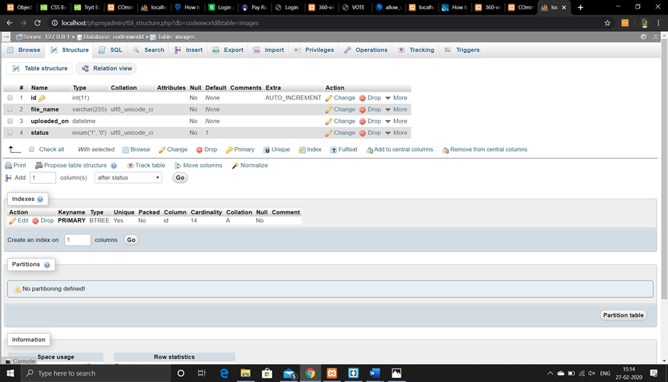

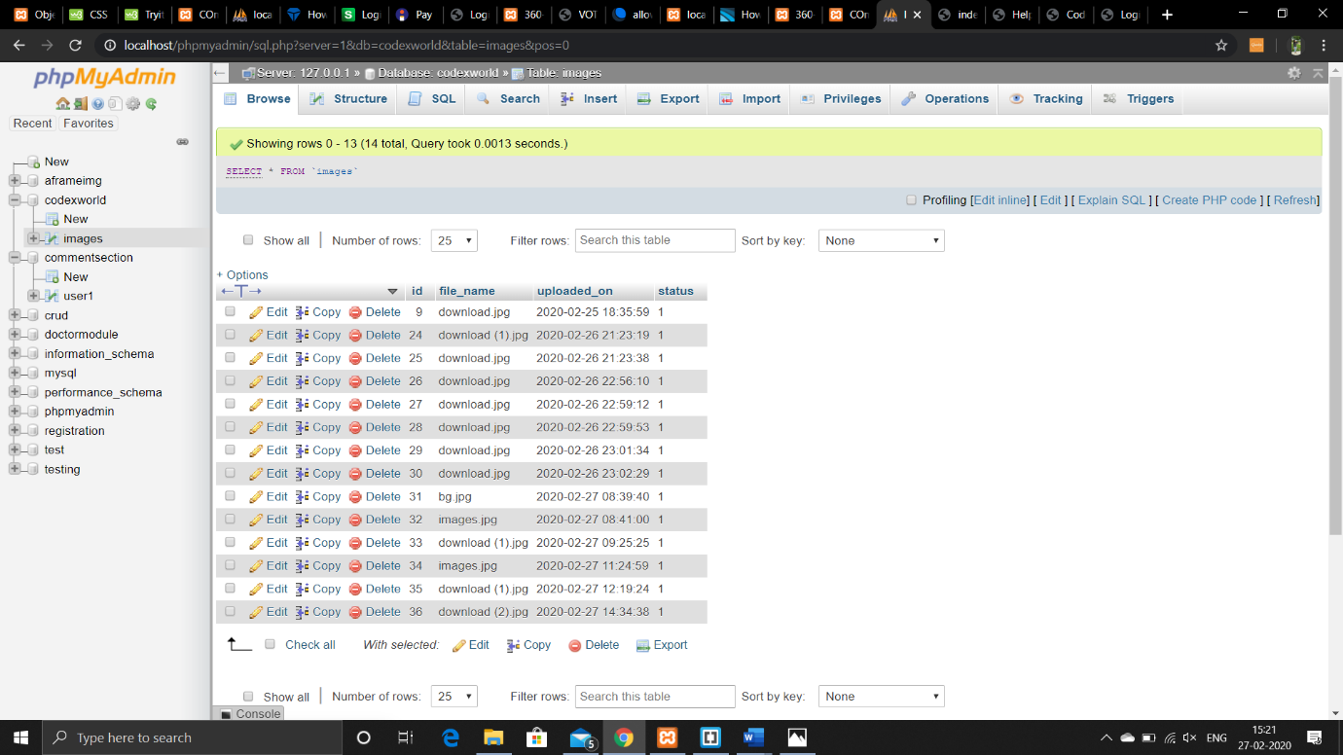

2)USER DETAILS TABLE

